**Databases Assignment**

**Group Number: A08- G4**

**Tutor Name: Saeed-Ul-Hassan**

**Mohammed Shah (21302180)**

**Mohammed Naeem Zaman (21363897)**

**Haseeb Nawaz (20019601)**

**Husnain Ahmed (21308666)**

**Table of Contents**

Section 1 - Executive Summary 3

Section 2: Database Design 4

2a - Top-Down ERD 5

2b - Bottom-Up ERD 7

2c - Merge of Top Down and Bottom Up ERD’s 11

Section 3: SQL Implementation 14

3a - Drop and Create Statements 15

3b - Insert Statements 19

3c – Screenshots of Insert Data 23

Section 4: Student Statements 33

Appendix A: Individual ERD Attempts 35

Appendix B: Logbook 40

Appendix C: Full SQL Code 45

# 

# Section 1 - Executive Summary

Databases are fundamental in any organization, in storing data of any information to do with the company and its documentation of any communication/transaction between stakeholders. This report will serve as documentation of the whole process of planning and creating a database for a business in need of improvement. This will be shown throughout the report using diagrams and command languages to supply a presentable report of the implementation of this database. The business in question is Mike’s Motorboats where they are a service that provides tourists that visit the area, the use to hire and purchase boats, whilst also being an overall boat maintenance company.

With every business, some issues will arise, where improvement is needed. With Mike’s Motorboats, some of these issues have been due to the current system in place. The current system implements a standard and basic pen and paper system to document all the customer detail on boat hiring/reservation. This can, and has, led to many complications in the past of double/overlapping reservations (overbooking) being set up and leaving the company with “embarrassment several times in the past.” An attempt was made to switch over to a modern, online database however, was unsuccessful due to poor planning/usability. Another problem of the current system includes the management of the stock of spare parts. This is due to documentation and records being written down for the stocks of spare parts being ill-managed and not allowing the correct stock check to be made (improper recording of stock numbers has led to “no real check” in deliveries and orders).

These issues are intended to be fixed with this report. This will start with sufficient planning being done before creating the database. This planning will include diagrams, ERDs, to provide an overview of all aspects that need to be considered in making the database. Multiple ERDs have been made with top-down, bottom-up, and fusion of both techniques to figure out all aspects to be considered in the business. Normalization has also been used, in this section, to figure out the attributes to be used in a set formation of primary keys and composite keys. The creation of the database is next and will be documented using SQL. These commands will be split up into the DROP and CREATE statements to make the tables and the INSERT statements to input data into the tables, including the evidence of the SELECT query results that will be used to access the information inside of the database.

# Section 2: Database Design

## 2a - Top-Down ERD

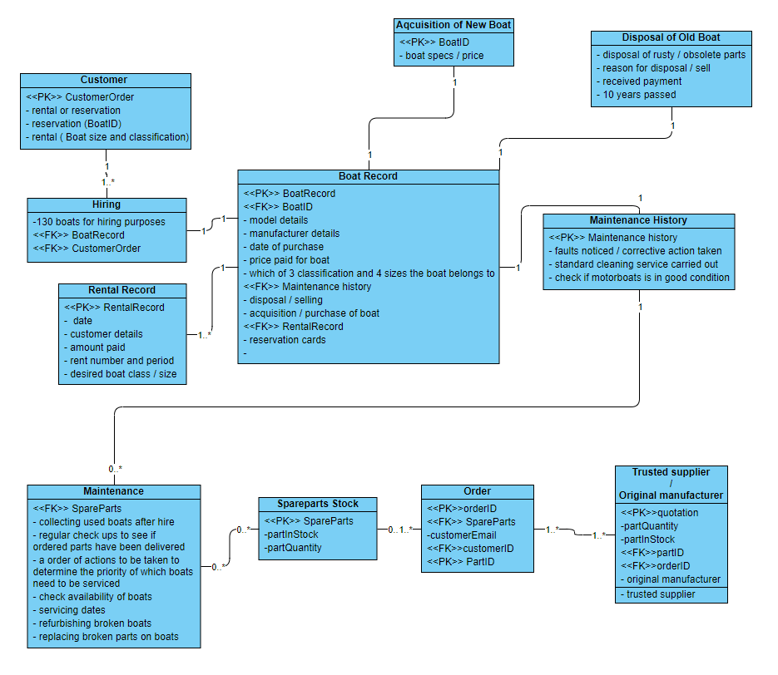

The diagram above is the top-down ERD, created by the group, using the individual ERDs each member made. Overall, all the individual ERDs are like each other and have led well into creating the full top-down ERD, with only minor differences that have been considered and used, if approved with the group. The majority of these similarities have been in the classes used, that are a necessity to Mike’s company, as many of these aspects have appeared on all ERDs produced. These consist of the boat records, maintenance, rental records, customer details, order details and disposal of a boat. Adding these was a unanimous decision. This also was the case for many of the attributes written within these classes, being the general details of the subject relating to that class (example – customers will have their own personal details be within that class). The minor changes needed to move from the individuals' diagrams to the final top-down ERD have been the extra classes needed to create a professional ERD to a high standard. The use of classes spare parts stock, hiring and maintenance history have been added to provide more data between certain classes improving the cardinality. The maintenance history has been added, separate to maintenance, to be more of a general spec to check on when it comes to the overall maintenance. Another decision made was to add more specific attributes into all classes that each individual though out, making sure we considered all aspects in Mike’s Motorboats. Some assumptions have been made in this ERD that will be evaluated on for the fusion ERD. The amount of data needed for the class/size entity is assumed enough to have its own class. This will be evaluated, alongside the acquisition of a new boat as an assumption has been made that this data can be stored in attributes, compared to its own class. An assumption made, and to be evaluated, will be the class of maintenance history could be merged to rental records to have all rental details in one class. The ‘order’ class could have two composite keys to replace the 4 keys being used, having merged the corresponding primary and foreign key.

## 2b - Bottom-Up ERD

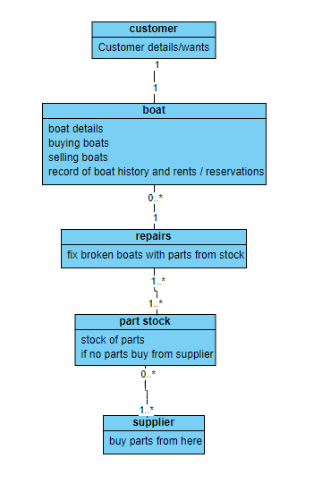

This is the bottom-up ERD, showing a simpler, less complex diagram. We had included the best attributes from everyone’s ERD to ensure we had a sample of the ERD to work on. When we had done this, we focused on including the best attributes and ensuring we meet the specification, the reason for this is because we had to ensure the bottom-up ERD combined the number of entities and attributes and to also ensure the top-down ERD and the bottom-up ERD were not similar at all. This is being used to take a different approach to the planning of the databases to create a better final, fusion ERD.

**Boat Record Normalisation**

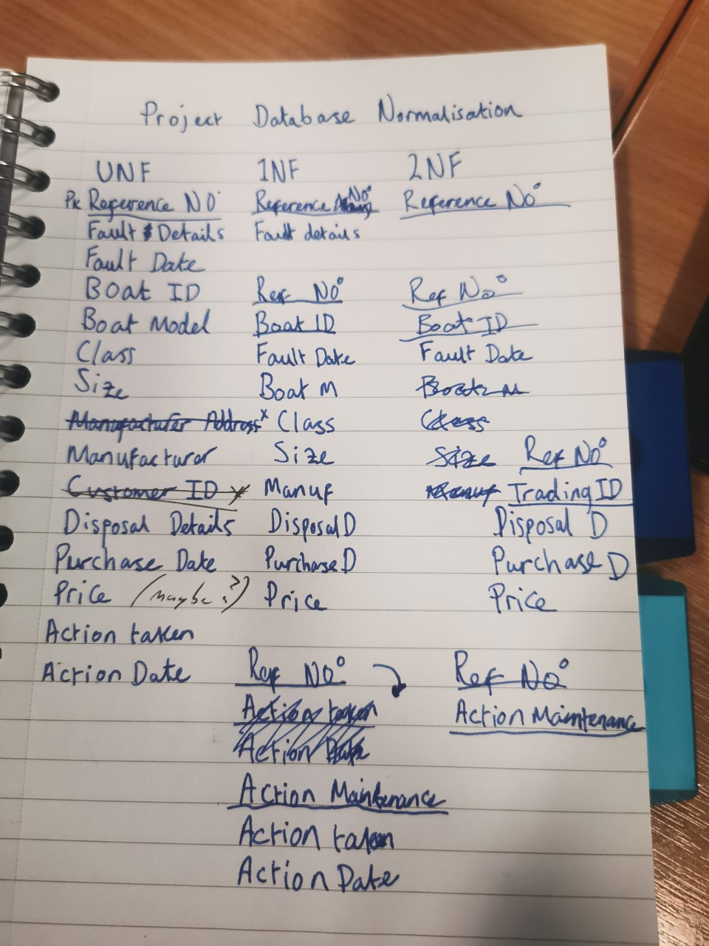

We decided to use a notepad instead of using Microsoft Excel, since the program were having some technical difficulties when we tried to save files. The issue couldn’t be resolved so we decided to write it out. The normalisation process helps us to find the keys (primary, foreign and composite) to be used in the final fusion ERD and for any searches in the final database. The normalisation process helped us with the other models because we had to inspect the primary and foreign keys. It organised the attributes and the relations of the database overall to ensure that their dependency is enforced. By the picture above you can see we had trial and error with the attributes because the different normalisations were to ensure there was no data redundancy and to enhance the data.

**Merged 3NFs from Normalisations and Bottom-Up Data Model**

There were no partial key dependencies, so we did not need to do this step.

## 2c - Merge of Top Down and Bottom Up ERD’s

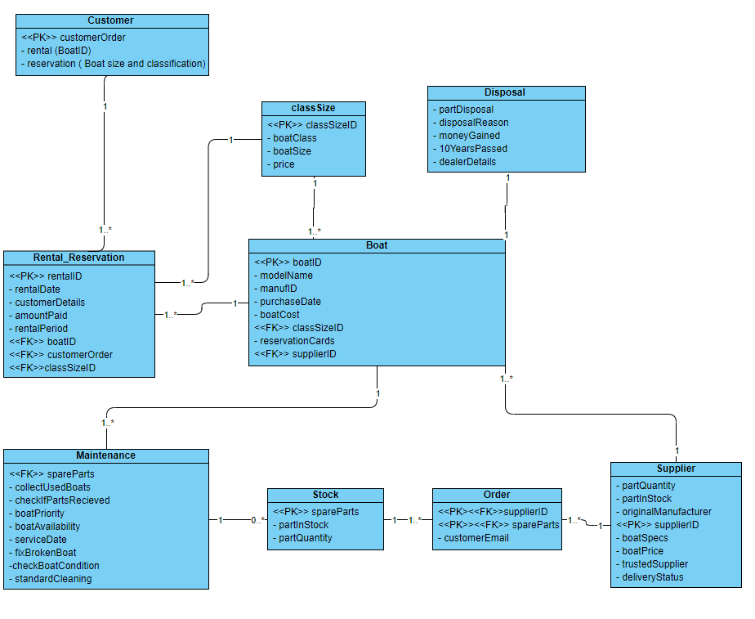

The above diagram is the final ERD to be made, being a fusion ERD (a merge of the Top-down & Bottom-Up ERD). This diagram has been made using the best aspects of both previous ERDs. The two ERD’s that were merged had allowed us to create this ERD that included the attributes from the top-down and the bottom-up ERD. This has been fully completed with the correct types of keys needed and all attributes correctly listed.

**2d - Changes made to the final Database when compared to the ERD:**

The changes we made in the final database when compared to the ERD was the fact that we changed the values we had in numerous tables within our ERD to match and reflect that of the specifications data- such as when we changed some values from the Customer table to include name, number, address, ID and email- we also did the same thing to supplier, maintenance and classsize- and also added a sell table to our database to show which boats had been sold.

When making the final database, some changes were made when compared to the ERD. The values used within numerous tables within our ERD were changed to reflect the data in the specification. An example of this was when changes to the Customer table’s data were made, including the name, phone number, address, ID and email. This implementation of data change was also done to the supplier, maintenance and class size. Another table was also needed to cover the sales, showing the boats that have been sold.

# Section 3: SQL Implementation

## 3a - Drop and Create Statements

## Drop any pre-existing tables

SET FOREIGN_KEY_CHECKS = 0;

DROP TABLE IF EXISTS customer;

DROP TABLE IF EXISTS classSize;

DROP TABLE IF EXISTS disposal;

DROP TABLE IF EXISTS boat;

DROP TABLE IF EXISTS rental_Reservation;

DROP TABLE IF EXISTS maintenance;

DROP TABLE IF EXISTS stock;

DROP TABLE IF EXISTS orders;

DROP TABLE IF EXISTS supplier;

DROP TABLE IF EXISTS sell;

SET FOREIGN_KEY_CHECKS = 1;

## Create the tables

CREATE TABLE customer (

customerID INT,

customerFName VARCHAR(32),

customerSName VARCHAR(32),

customerNum VARCHAR(32),

customerAdd VARCHAR(64),

customerEmail VARCHAR(32)

);

CREATE TABLE supplier (

supplierID INT,

manufName VARCHAR(64),

manufNum VARCHAR(32),

manufAdd VARCHAR(64),

manufEmail VARCHAR(32),

partinStock VARCHAR(32),

partQuantity INT,

boatSpecs VARCHAR(32),

boatPrice INT,

deliveryStatus VARCHAR(32),

PRIMARY KEY (supplierID)

);

CREATE TABLE boat (

boatID INT,

modelName VARCHAR(32),

manufID INT,

purchaseDate VARCHAR(32),

boatCost INT,

boatType VARCHAR(32),

reservationCards VARCHAR(32),

lastService VARCHAR(32),

PRIMARY KEY (boatID),

supplierID INT,

FOREIGN KEY (supplierID) REFERENCES supplier(supplierID)

);

CREATE TABLE maintenance (

boatID INT,

refNo INT,

faultDetails VARCHAR(32),

faultDate VARCHAR(32),

actionTaken VARCHAR(32),

actionDate VARCHAR(32),

boatPriority INT,

spareParts VARCHAR(32) REFERENCES stock(spareParts)

);

CREATE TABLE classSize (

`priceFull` INT,

`priceHalf` INT,

`boatType` VARCHAR(32)

);

CREATE TABLE rental_Reservation (

custNo INT REFERENCES customer(customerID),

resNo INT,

paid VARCHAR(32),

rentalDate VARCHAR(32),

boatType VARCHAR(32) REFERENCES boat(boatType),

days VARCHAR(32),

hirePrice INT,

boatID INT REFERENCES boat(boatID),

dueDate VARCHAR(32),

returnDate VARCHAR(32),

cName VARCHAR(32),

email VARCHAR(32),

postcode VARCHAR(32),

tel VARCHAR(32)

);

CREATE TABLE disposal (

dealerID INT,

dealerName VARCHAR(64),

dealerNum VARCHAR(32),

dealerAdd VARCHAR(64),

dealerEmail VARCHAR(32)

);

CREATE TABLE sell (

DealerID INT,

boatID INT ,

sellDate VARCHAR(32),

sellPrice INT

);

CREATE TABLE stock (

spareParts VARCHAR(32) PRIMARY KEY,

partID INT,

partinStock VARCHAR(32),

partQuantity INT

);

CREATE TABLE orders (

supplierID NUMERIC,

spareParts VARCHAR(32),

PRIMARY KEY (supplierID,spareParts),

customerEmail VARCHAR(32)

);

## 3b - Insert Statements

INSERT INTO boat (boatID, modelName, manufID, purchaseDate, boatCost, boatType, lastService)

VALUES (

1, 'Explorer', 1, '22-Nov-10', 3910, 'Std_MBoat', '22-oct-20'

);

INSERT INTO customer (customerID, customerFName, customerSName, customerNum, customerAdd, customerEmail)

VALUES (

1, 'Dion', 'Brodnecke', '07174826351', '9 Oak Street, Liverpool, L34 8DY', 'dbroes1d@who.int'

);

INSERT INTO disposal (dealerID, dealerName, dealerNum, dealerAdd, dealerEmail)

VALUES (

1, 'Dalis Vannoort', '07574137463', '77 A828, Appin, AP7 6GU', 'dvannoort0@salon.com'

);

INSERT INTO supplier (manufID, manufName, manufNum, manufAdd, manufEmail)

VALUES (

1,' SuperBoat', '01772459666', ' Unit 7 Centurion Court, Leyland, LE10 2DJ', ' admin@superboat.co.uk'

);

INSERT INTO classSize (`priceFull`, `priceHalf`, `boatType`)

VALUES

(240, 170, 'VLrg_SBoat'),

(180, 120, 'Lrg_SBoat'),

(160, 100, 'Std_SBoat'),

(140, 90, 'Sml_SBoat'),

(280, 175, 'VLrg_MBoat'),

(240, 150,'Lrg_MBoat'),

(200, 125, 'Std_MBoat'),

(170, 110, 'Sml_MBoat'),

(160, 100, 'VLrg_RBoat'),

(140, 90, 'Lrg_RBoat'),

(120, 80, 'Std_RBoat'),

(110, 70, 'Sml_RBoat');

INSERT INTO sell (DealerID, boatID, sellDate, sellPrice)

VALUES

(2, 1, '02-Jan-2020', 1500),

(2, 2, '10-Oct-2019', 1600);

INSERT INTO maintenance (boatID, refNo, faultDetails, faultDate, actionTaken, actionDate, boatPriority)

VALUES

(1, 1, 'Chipped propeller', '15feb15', 'Replace Propeller', '27feb15', 3),

(1, 2, 'Bilge pumps gone', '10jul15', 'New bilge pumps', '27aug15', 1),

(1, 3, '', '', 'Replace Propeller', '27feb15', 2),

(1, 4, '', '', 'Replace Propeller', '27feb15', 2),

(1, 5, 'Cutless bearing worn through', '02dec16', 'Fit new bearing ', '27jan17', 2);

INSERT INTO rental_Reservation (custNo, resNo, paid, rentalDate, boatType, Days, hirePrice, boatID)

VALUES

(1, 5344, 'Y', '20-10-2020', 'Lrg Rboat', 1, 280, 9),

(2, 5345, 'Y', '20-10-2020', ' Sml Rboat', 1, 220, 16),

(9, 5347, 'Y', '20-10-2020', 'Lrg Mboat', 1, 240, 7),

(4, 5346, 'Y', '20-10-2020', 'Lrg Mboat', 1, 240, 6),

(7, 5349, 'Y', '20-10-2020', 'Lrg Rboat', 1, 140, 9),

(6, 5348, 'Y', '20-10-2020', 'Lrg Mboat', 1, 240, 15),

(2, 5350, 'Y', '20-10-2020', 'Lrg Sboat', 1, 180, 9),

(5, 5352, 'Y', '20-10-2020', 'Lrg Rboat', 1, 110, 16),

(5, 5353, 'Y', '20-10-2020', 'Sml Rboat', 1, 110, 17),

(9, 5354, 'Y', '20-10-2020', 'Std Mboat', 2, 400, 14),

(2, 5351, 'Y', '20-10-2020', 'Lrg Sboat', 1, 180, 11),

(8, 5364, 'Y', '20-10-2020', 'Sml Sboat', 1, 110, 4),

(9, 5355, 'Y', '20-10-2020', 'Std Mboat', 2, 400, 13),

(1, 5356, 'Y', '20-10-2020', 'Std Mboat', 1, 200, 8),

(6, 5357, 'Y', '20-10-2020', 'Std Mboat', 1, 120, 1),

(7, 5358, 'Y', '20-10-2020', 'Std RBoat', 1, 280, 10),

(10, 5366, 'Y', '20-10-2020', 'Std Rboat', 0.5, 80, 21),

(4, 5360, 'Y', '20-10-2020', 'VLrg Mboat', 1, 280, 20),

(8, 5361, 'Y', '20-10-2020', 'VLrg Sboat', 1, 240, 2),

(10, 5359, ' ', '20-10-2020', 'Std Sboat', 1, 160, NULL),

(3, 5362, ' ', '20-10-2020', 'VLrg Rboat', 1, 100, NULL),

(3, 5365, ' ', '20-10-2020', 'Std Rboat', 1, 120, NULL),

(3, 5363, ' ', '20-10-2020', 'VLrg Rboat', 1, 100, NULL),

(1, 5342, 'Y', '27-04-2020', 'Lrg Sboat', 1, 180, 16),

(4, 5341, ' ', '20-10-2019', 'Lrg Mboat', 1, 240, 6),

(2, 5343, 'Y', '09-12-2019', 'Lrg Mboat', 1, 240, 6),

(1, 5673, ' ', '24-10-2019', 'Lrg Sboat', 1, 180, 1),

(2, 5972, ' ', '25-10-2019', 'Lrg Mboat', 1, 240, 6),

(3, 5353, 'Y', '26-10-2019', 'Lrg Sboat', 1, 180, 9),

(4, 5835, ' ', '27-10-2019', 'Lrg Rboat', 1, 110, 5),

(5, 5856, 'Y', '28-10-2019', 'Std Rboat', 1, 120, 1);

INSERT INTO stock (spareParts, partID, partInStock, partQuantity)

VALUES

('Propeller',1, 'Y', 2),

('Sail',2, 'Y', 6),

('Bearings',3, 'Y', 20),

('Bilge pumps',4, 'N', 0),

('Rudder blade',5, 'N', 0);

INSERT INTO orders (supplierID, spareParts, customerEmail)

VALUES

(1, 'Propeller', 'CBones@italia.it'),

(2, 'Sail', 'CBooney@america.com'),

(3, 'Bearings', 'CBooms@jean.co.uk'),

(4, 'Bilge pumps', 'CBand@lore.it'),

(5, 'Rudder blade', 'CBaba@boom.jp');

## 3c – Screenshots of Insert Data

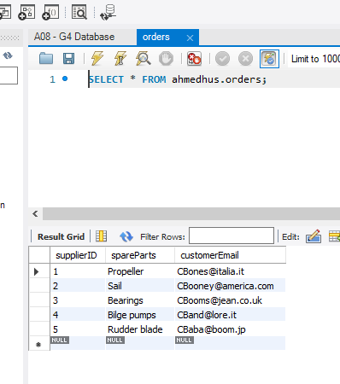

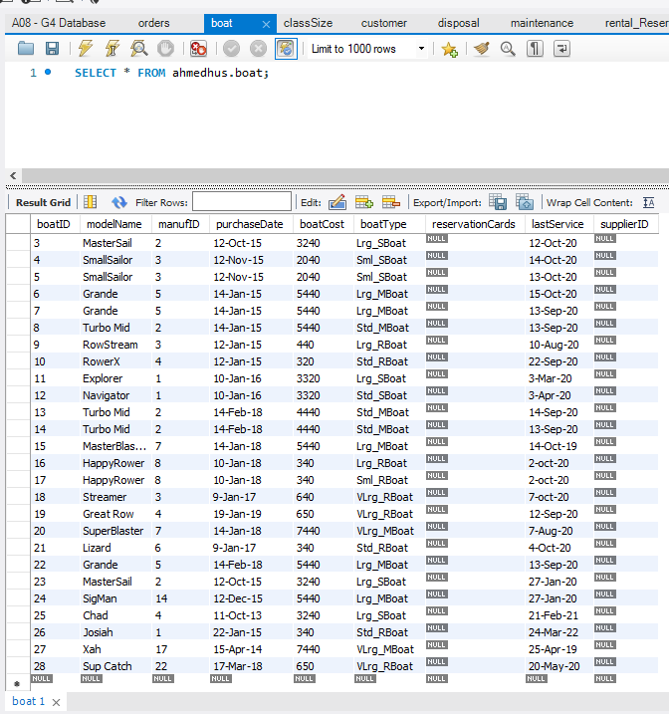

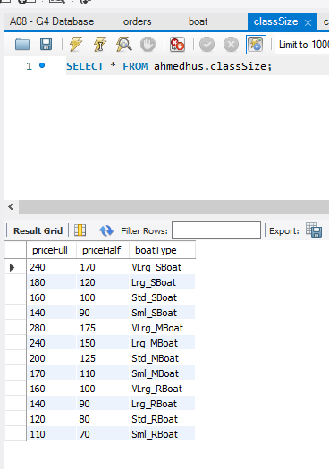

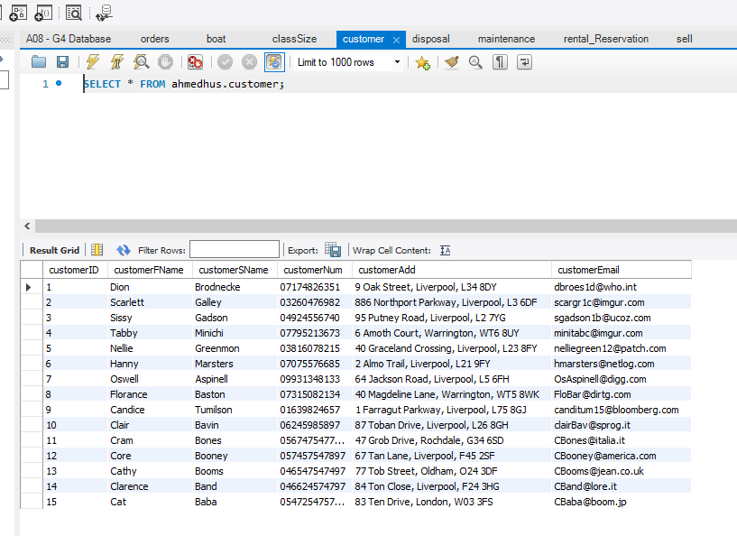

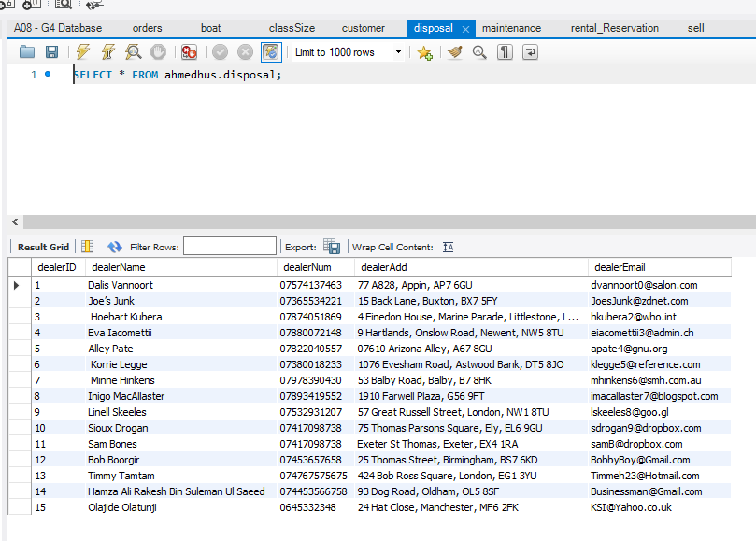

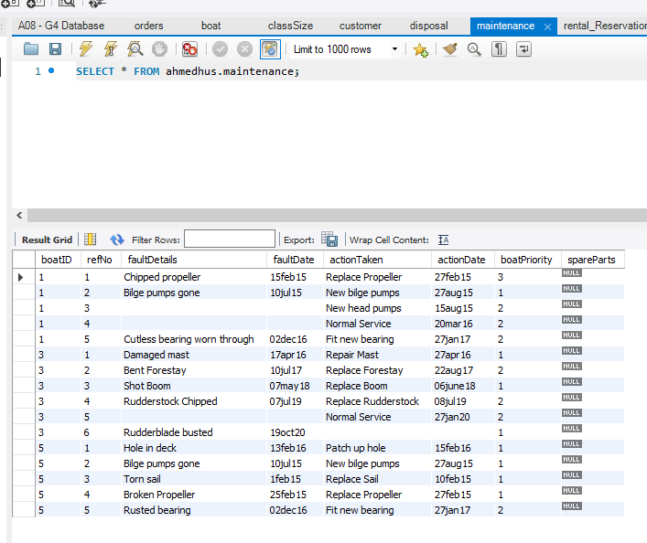

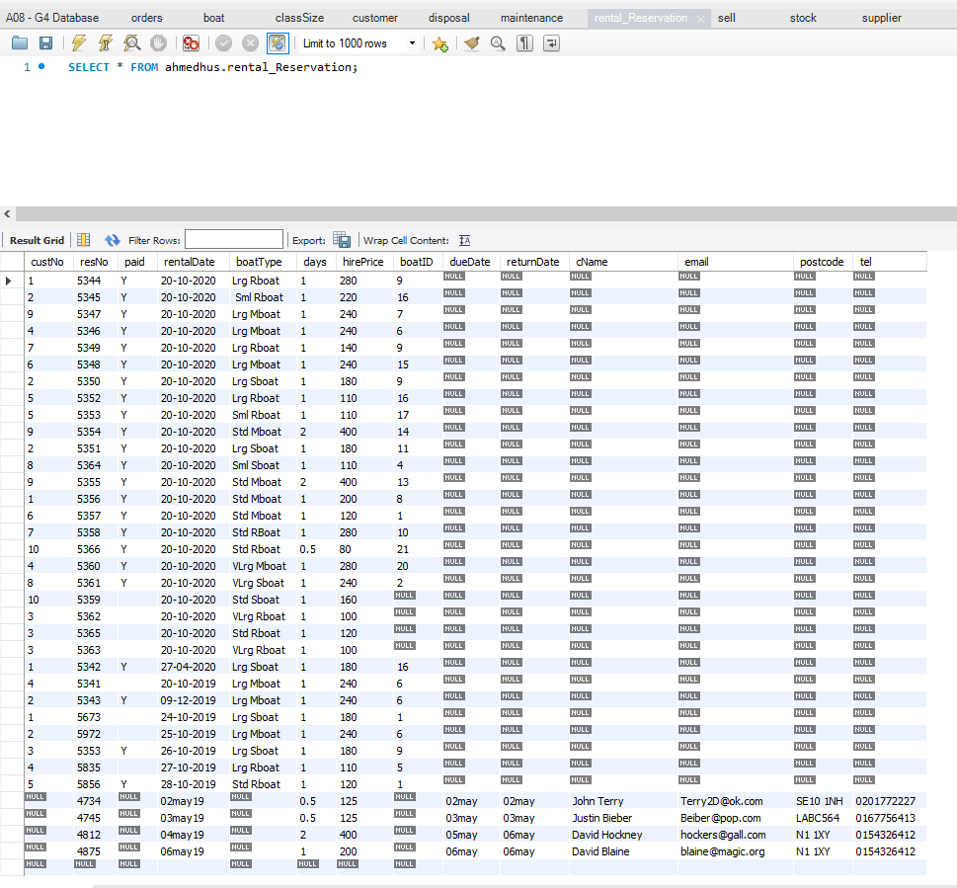

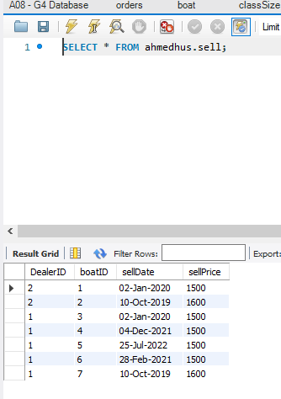

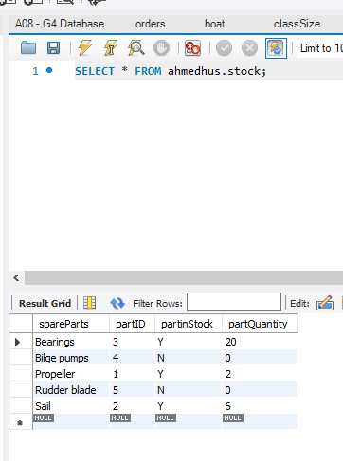

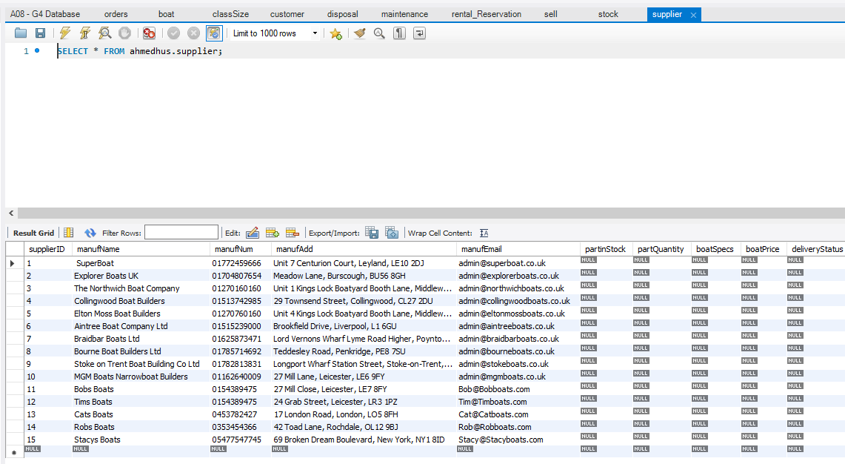

# **Section 4: Student Statements**

**Student A – Mohammed Shah (21302180)**

Throughout the course of the 6 weeks, my team and I have learnt many things about SQL- ERD’s, RDA’s and have also learnt to communicate much better, especially since this project required a lot of input from everyone especially on ERD’s as it is heavily opinion-based however we pulled through and personally I have found SQL interesting to learn. I’ve learnt how to use INSERT and CREATE statements, and this has helped, especially in this unit- not to mention the fact that through getting ready for this unit with SQL Tester I felt my knowledge and understanding of the topic increase exponentially.

**Student B – Mohammed Naeem Zaman (21363897)**

During the past 6 weeks I have learnt what databases are and how we can create ERD’s. It has shown us how important databases are within businesses and how we interact with them daily. On the other hand, it has also taught me how important soft skills are when it comes to group projects. Certain skills such as communication, problem-solving and teamworking skills are essential and it had me implement these skills into something productive such as creating the top-down and bottom-up ERD’s. On the other hand, SQL made me have a deeper understanding of the whole unit because of how data has been laid out. It’s not just writing information down it’s also storing the data and ensuring it makes the business run more efficiently.

**Student C – Haseeb Nawaz (20019601)**

This whole project has allowed me to look inside the inner working of a business and, more importantly, the usages of programming with storing data and have proper function over all data stored for a certain company. The use of ERDs have shown me the necessary factors and aspects that need to be consider when storing data in a database for a certain scenario for a company. SQL has shown me the communication and commands needed between the databases and the user, to make any change to data. This is also my introduction into group work and the many skills needed to produce a final, presentable group project.

**Student D – Husnain Ahmed (21308666)**

Over the course of this unit, I have learnt about databases as a whole; what they are, their purpose and functionality. I now understand the importance of databases and how they are used in businesses to store data. I have learned how to design a database in the form of an Entity Relationship Diagram that can be used to form tables of data in MYSQL Workbench (MariaDB). I have also learned the basics of the SQL programming language and know how to do SQL queries. I believe that this unit was important for me as it was my first experience with working in a group and I have learnt valuable teamwork skills and improved my skills with communication and my overall confidence and skillset.

# Appendix A: Individual ERD Attempts

Husnain Ahmed’s Individual ERD (21308666)

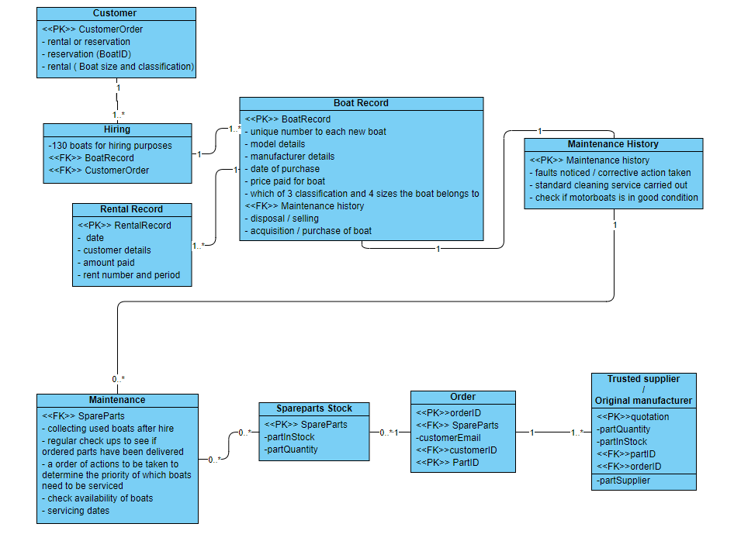

Mohammed Shah’s Individual ERD (21302180)

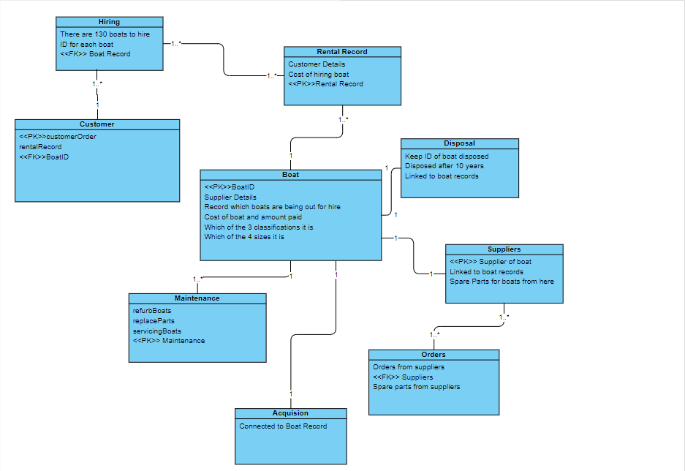

Mohammed Naeem Zaman’s Individual ERD (21363897)

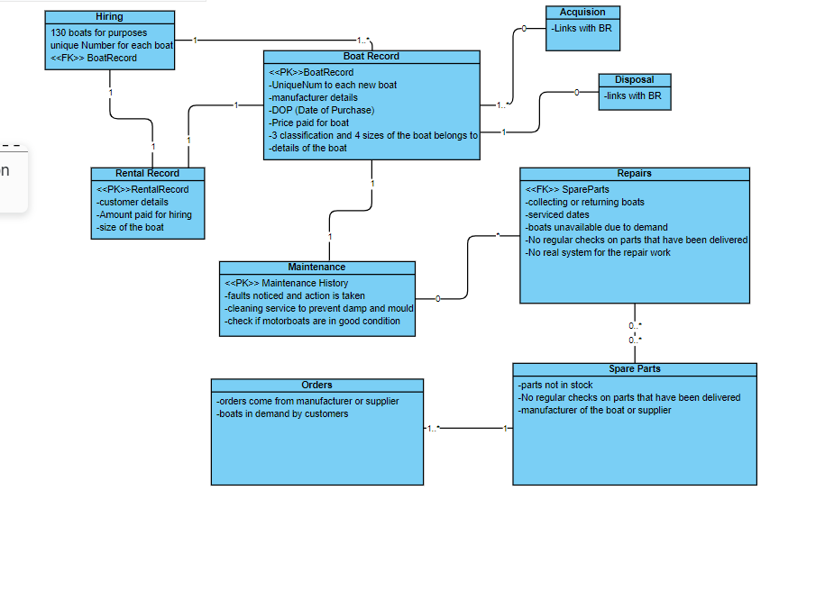

Haseeb Nawaz’s Individual ERD (20019601)

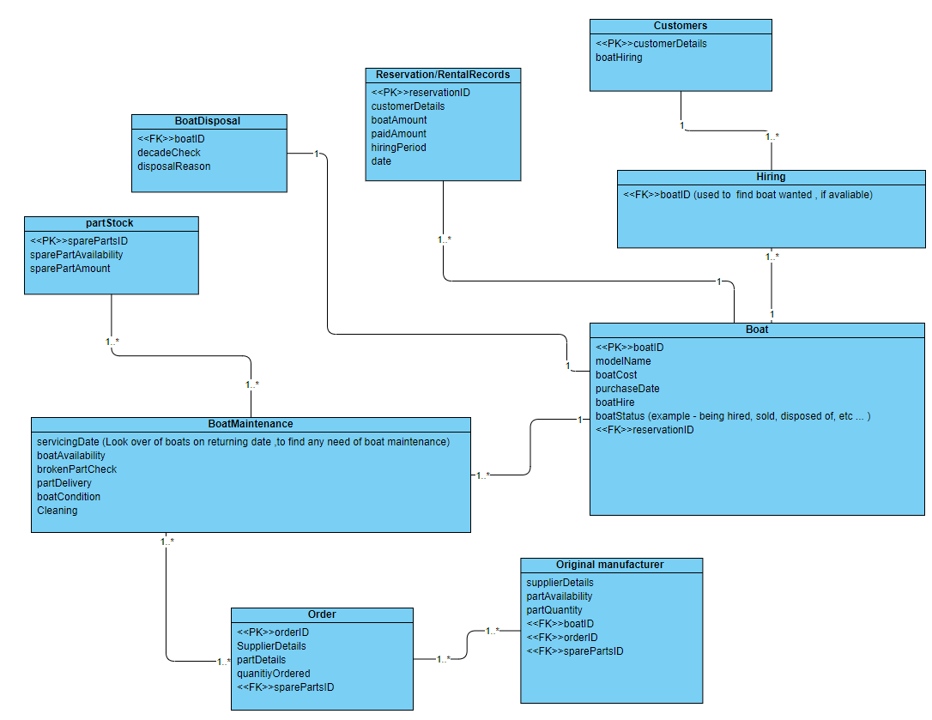

# Appendix B: Logbook

**Log 01 - Group 4**

**Date:** 04/02/2022

**Names of those present:** Shah, Haseeb

**Names of those absent:** N/A

**What was discussed:** Looking through the problems with the existing database and think about how they can be improved upon / solved

**Action plan:** Meet up on 09/02/2022 to review our current progress - we will utilise WhatsApp and Discord for communication- through these platforms, we will review the work and produce our group ERD.

**Log 02 - Group 4**

**Date:** 10/02/2022

**Names of those present:** Husnain, Naeem, Shah

**Names of those absent:** Haseeb

**What was discussed:** 2 new group members (Husnain Ahmed and Mohammed Naeem Zaman) have joined the group.

Haseeb was ill so he sent his individual Erd to us for the group Erd.

We have pooled together our individual Erd's to form a top-down group Erd.

**Action plan:** Start on bottom down ERD’s.

**Log 03 - Group 4**

**Date:** 15/02/2022

**Names of those present:** everyone present

**Names of those absent:** N/A

**What was discussed:** We all made the bottom-up ERD and fused it with the top down erd we made previously for our final erd.

**Action plan:** Next time we will plan our actual database and make it in SQL workbench.

**Log 04 - Group 4**

**Date:** 16/02/2022

**Names of those present:** Today 3/4 have arrived- Haseeb, Naeem and Shah

**Names of those absent:** Husnain is absent due to a transport problem- affecting his train lines

**What was discussed:** We have begun the Group Report in our session today and have also consulted our tutor on our fusion ERD we have found we have some improvements to make.

Husnain is currently supplying us digital support through the use of Discord.

We have completed our individual ERD's and are now focusing on completing our Fusion ERD and are planning to start our SQL.

**Action plan:** Start SQL

**Log 05 - Group 4**

**Date:** 22/02/2022

**Names of those present:** Haseeb and Shah

**Names of those absent:** Husnain and Naeem are not in due to the weather affecting their transport.

**What was discussed:** we have managed to create our fused ERD with insight from our tutor- and have decided to begin the creation of our group database and the designing of the database

**Action plan:** We have decided to start with the Create Statements first and will move to the SELECT and INSERT statements next.

**Log 06 - Group 4**

**Date:** 24/02/2022

**Names of those present:** Haseeb, Husnain, and Shah

**Names of those absent:** Naeem was absent but cooperated with us through Discord

**What was discussed:** with our joint efforts we submitted our Finalised Group ERD's after 8 revisions and our tutor's feedback. We Redid our Normalisation as we had no evidence of previously going through the process of doing so.

**Action plan:** next time we will start on the database and get familiar with Maria DB.

**Log 07 - Group 4**

**Date:**  02/03/2022

**Names of those present:**  Husnain, Naeem, Shah, Haseeb

**Names of those absent:**  N/A

**What was discussed:**  We did work on our report and uploaded our individual ERD's to it in the appendix as well as write a summary and upload our previous logbooks to the appendix.

We also added all our group Erd's (the top down, bottom up, normalisation and final fused one).

**Action plan:** Next time we will start on the database and upload some information to tables such as the class and sizes of boats and their prices.

**Log 08 - Group 4**

**Date:**  03/03/2022

**Names of those present:**  Husnain, Naeem

**Names of those absent:**  Shah, Haseeb

**What was discussed:**  Naeem added more information to the report while Husnain started on the database.

**Action plan:** Next week on Monday 07/03/2020 the entire group will meet up on the university campus and do some work on the database and hopefully finish it in its entirety.

**Log 09 - Group 4**

**Date:**  06/03/2022

**Names of those present:**  Husnain

**Names of those absent:**  Shah, Haseeb, Naeem

**What was discussed:**  Husnain did work at home by himself on the database for an hour and almost finished the create statements, there were some issues with foreign keys not locating the primary keys in other tables.

**Action plan:** Fix the issues with the foreign keys and get started on the insert statements.

**Log 10 - Group 4**

**Date:**  06/03/2022

**Names of those present:**  Husnain

**Names of those absent:**  Shah, Haseeb, Naeem

**What was discussed:**  Husnain fixed the issue with the foreign keys by adding a blank value for the foreign keys to override.

**Action plan:** Get started on the insert statements.

**Log 11 - Group 4**

**Date:** 07/03/2022

**Names of those present:** Shah, Haseeb, Husnain

**Names of those absent:** Naeem

**What was discussed:** We got started on the INSERT statements today, we split the INSERT statements equally between Shah and Husnain- and got most of the data inserted into the tables- Haseeb has begun formatting the report and is rewriting it.

**Action plan:** Finish off the INSERT statements (3 tables left) and start on the SELECT statements.

**Log 12 - Group 4**

**Date:** 09/03/2022

**Names of those present:** Husnain, Naeem, Shah, Haseeb

**Names of those absent:** none

**What was discussed:** Husnain and Shah are working on the SQL trying to fill in the missing gaps whereas Haseeb and Naeem are working and checking on the report trying to ensure that it meets with the specification.

**Action plan:** Finish off the database

**Log 13 - Group 4**

**Date:** 10/03/2022

**Names of those present:** Shah, Husnain, Naeem

**Names of those absent:** Haseeb

**What was discussed:** Husnain, Naeem and Shah are working on the SQL- we have contacted Stephen and he's given us the right information to improve on our database- Naeem is supervising the report after Haseeb finished the report- Naeem is looking to make any corrections and improvements through proofreading.

**Action plan:** We will try get our insert statements done.

**Log 14 - Group 4**

**Date:** 10/03/2022

**Names of those present:** Shah, Husnain, Haseeb and Naeem

**Names of those absent:** None

**What was discussed:** We have completed the CREATE tables- and Husnain has so far done the biggest parts within the Database- with additional help from Shah, Haseeb and Naeem-

**Action plan:**  We will try fix the errors remaining in the SQL- which are some INSERT statements.

**Log 15 - Group 4**

**Date:** 10/03/2022

**Names of those present:** Shah and Husnain

**Names of those absent:** Naeem and Haseeb

**What was discussed:** We completed most of the INSERT statements and have only spare parts to complete in the database.

**Action plan:** Fixing the spare parts table tomorrow.

**Log 16 - Group 4**

**Date:** 11/03/2022

**Names of those present:** Shah, Husnain, Haseeb and Naeem

**Names of those absent:** None

**What was discussed:** We have finished off the database and are now pooling in to finish the report.

**Action plan:** Nothing- we've finished.

# Appendix C: Full SQL Code

## Drop any pre-existing tables

SET FOREIGN_KEY_CHECKS = 0;

DROP TABLE IF EXISTS customer;

DROP TABLE IF EXISTS classSize;

DROP TABLE IF EXISTS disposal;

DROP TABLE IF EXISTS boat;

DROP TABLE IF EXISTS rental_Reservation;

DROP TABLE IF EXISTS maintenance;

DROP TABLE IF EXISTS stock;

DROP TABLE IF EXISTS orders;

DROP TABLE IF EXISTS supplier;

DROP TABLE IF EXISTS sell;

SET FOREIGN_KEY_CHECKS = 1;

## Create the tables

CREATE TABLE customer (

customerID INT,

customerFName VARCHAR(32),

customerSName VARCHAR(32),

customerNum VARCHAR(32),

customerAdd VARCHAR(64),

customerEmail VARCHAR(32)

);

CREATE TABLE supplier (

supplierID INT,

manufName VARCHAR(64),

manufNum VARCHAR(32),

manufAdd VARCHAR(64),

manufEmail VARCHAR(32),

partinStock VARCHAR(32),

partQuantity INT,

boatSpecs VARCHAR(32),

boatPrice INT,

deliveryStatus VARCHAR(32),

PRIMARY KEY (supplierID)

);

CREATE TABLE boat (

boatID INT,

modelName VARCHAR(32),

manufID INT,

purchaseDate VARCHAR(32),

boatCost INT,

boatType VARCHAR(32),

reservationCards VARCHAR(32),

lastService VARCHAR(32),

PRIMARY KEY (boatID),

supplierID INT,

FOREIGN KEY (supplierID) REFERENCES supplier(supplierID)

);

CREATE TABLE maintenance (

boatID INT,

refNo INT,

faultDetails VARCHAR(32),

faultDate VARCHAR(32),

actionTaken VARCHAR(32),

actionDate VARCHAR(32),

boatPriority INT,

spareParts VARCHAR(32) REFERENCES stock(spareParts)

);

CREATE TABLE classSize (

`priceFull` INT,

`priceHalf` INT,

`boatType` VARCHAR(32)

);

CREATE TABLE rental_Reservation (

custNo INT REFERENCES customer(customerID),

resNo INT,

paid VARCHAR(32),

rentalDate VARCHAR(32),

boatType VARCHAR(32) REFERENCES boat(boatType),

days VARCHAR(32),

hirePrice INT,

boatID INT REFERENCES boat(boatID),

dueDate VARCHAR(32),

returnDate VARCHAR(32),

cName VARCHAR(32),

email VARCHAR(32),

postcode VARCHAR(32),

tel VARCHAR(32)

);

CREATE TABLE disposal (

dealerID INT,

dealerName VARCHAR(64),

dealerNum VARCHAR(32),

dealerAdd VARCHAR(64),

dealerEmail VARCHAR(32)

);

CREATE TABLE sell (

DealerID INT,

boatID INT ,

sellDate VARCHAR(32),

sellPrice INT

);

CREATE TABLE stock (

spareParts VARCHAR(32) PRIMARY KEY,

partID INT,

partinStock VARCHAR(32),

partQuantity INT

);

CREATE TABLE orders (

supplierID NUMERIC,

spareParts VARCHAR(32),

PRIMARY KEY (supplierID,spareParts),

customerEmail VARCHAR(32)

);

## Insert data into the tables

INSERT INTO boat (boatID, modelName, manufID, purchaseDate, boatCost, boatType, lastService)

VALUES (

1, 'Explorer', 1, '22-Nov-10', 3910, 'Std_MBoat', '22-oct-20'

);

INSERT INTO boat (boatID, modelName, manufID, purchaseDate, boatCost, boatType, lastService)

VALUES (

2, 'TurboSail ', 2, '12-Oct-09', 840, 'VLrg_SBoat', '8-Oct-19'

);

INSERT INTO boat (boatID, modelName, manufID, purchaseDate, boatCost, boatType, lastService)

VALUES (

3, 'MasterSail ', 2, '12-Oct-15', 3240, 'Lrg_SBoat', '12-Oct-20'

);

INSERT INTO boat (boatID, modelName, manufID, purchaseDate, boatCost, boatType, lastService)

VALUES (

4, 'SmallSailor', 3, '12-Nov-15', 2040, 'Sml_SBoat', '14-Oct-20'

);

INSERT INTO boat (boatID, modelName, manufID, purchaseDate, boatCost, boatType, lastService)

VALUES (

5, 'SmallSailor', 3, '12-Nov-15', 2040, 'Sml_SBoat', '13-Oct-20'

);

INSERT INTO boat (boatID, modelName, manufID, purchaseDate, boatCost, boatType, lastService)

VALUES (

6, 'Grande', 5, '14-Jan-15', 5440, 'Lrg_MBoat', '15-Oct-20'

);

INSERT INTO boat (boatID, modelName, manufID, purchaseDate, boatCost, boatType, lastService)

VALUES (

7, 'Grande', 5, '14-Jan-15', 5440, 'Lrg_MBoat', '13-Sep-20'

);

INSERT INTO boat (boatID, modelName, manufID, purchaseDate, boatCost, boatType, lastService)

VALUES (

8, 'Turbo Mid ', 2, '14-Jan-15', 5440, 'Std_MBoat', '13-Sep-20'

);

INSERT INTO boat (boatID, modelName, manufID, purchaseDate, boatCost, boatType, lastService)

VALUES (

9, 'RowStream', 3, '12-Jan-15', 440, 'Lrg_RBoat', '10-Aug-20'

);

INSERT INTO boat (boatID, modelName, manufID, purchaseDate, boatCost, boatType, lastService)

VALUES (

10, 'RowerX', 4, '12-Jan-15', 320, 'Std_RBoat', '22-Sep-20'

);

INSERT INTO boat (boatID, modelName, manufID, purchaseDate, boatCost, boatType, lastService)

VALUES (

11, 'Explorer', 1, '10-Jan-16', 3320, 'Lrg_SBoat', '3-Mar-20'

);

INSERT INTO boat (boatID, modelName, manufID, purchaseDate, boatCost, boatType, lastService)

VALUES (

12, 'Navigator', 1, '10-Jan-16', 3320, 'Std_SBoat', '3-Apr-20'

);

INSERT INTO boat (boatID, modelName, manufID, purchaseDate, boatCost, boatType, lastService)

VALUES (

13, 'Turbo Mid', 2, '14-Feb-18', 4440, 'Std_MBoat', '14-Sep-20'

);

INSERT INTO boat (boatID, modelName, manufID, purchaseDate, boatCost, boatType, lastService)

VALUES (

14, 'Turbo Mid', 2, '14-Feb-18', 4440, 'Std_MBoat', '13-Sep-20'

);

INSERT INTO boat (boatID, modelName, manufID, purchaseDate, boatCost, boatType, lastService)

VALUES (

15, 'MasterBlaster', 7, '14-Jan-18', 5440, 'Lrg_MBoat', '14-Oct-19'

);

INSERT INTO boat (boatID, modelName, manufID, purchaseDate, boatCost, boatType, lastService)

VALUES (

16, 'HappyRower', 8, '10-Jan-18', 340, 'Lrg_RBoat', '2-oct-20'

);

INSERT INTO boat (boatID, modelName, manufID, purchaseDate, boatCost, boatType, lastService)

VALUES (

17, 'HappyRower', 8, '10-Jan-18', 340, 'Sml_RBoat', '2-oct-20'

);

INSERT INTO boat (boatID, modelName, manufID, purchaseDate, boatCost, boatType, lastService)

VALUES (

18, 'Streamer', 3, '9-Jan-17', 640, 'VLrg_RBoat', '7-oct-20'

);

INSERT INTO boat (boatID, modelName, manufID, purchaseDate, boatCost, boatType, lastService)

VALUES (

19, 'Great Row', 4, '19-Jan-19', 650, 'VLrg_RBoat', '12-Sep-20'

);

INSERT INTO boat (boatID, modelName, manufID, purchaseDate, boatCost, boatType, lastService)

VALUES (

20, 'SuperBlaster', 7, '14-Jan-18', 7440, 'VLrg_MBoat', '7-Aug-20'

);

INSERT INTO boat (boatID, modelName, manufID, purchaseDate, boatCost, boatType, lastService)

VALUES (

21, 'Lizard', 6, '9-Jan-17', 340, 'Std_RBoat', '4-Oct-20'

);

INSERT INTO boat (boatID, modelName, manufID, purchaseDate, boatCost, boatType, lastService)

VALUES (

22, 'Grande', 5, '14-Feb-18', 5440, 'Lrg_MBoat', '13-Sep-20'

);

INSERT INTO boat (boatID, modelName, manufID, purchaseDate, boatCost, boatType, lastService)

VALUES (

23, 'MasterSail', 2, '12-Oct-15', 3240, 'Lrg_SBoat', '27-Jan-20'

);

INSERT INTO boat (boatID, modelName, manufID, purchaseDate, boatCost, boatType, lastService)

VALUES

(24, 'SigMan', 14, '12-Dec-15', 5440, 'Lrg_MBoat', '27-Jan-20'),

(25, 'Chad', 4, '11-Oct-13', 3240, 'Lrg_SBoat', '21-Feb-21'),

(26, 'Josiah', 1, '22-Jan-15', 340, 'Std_RBoat', '24-Mar-22'),

(27, 'Xah', 17, '15-Apr-14', 7440, 'VLrg_MBoat', '25-Apr-19'),

(28, 'Sup Catch', 22, '17-Mar-18', 650, 'VLrg_RBoat', '20-May-20');

INSERT INTO customer (customerID, customerFName, customerSName, customerNum, customerAdd, customerEmail)

VALUES (

1, 'Dion', 'Brodnecke', '07174826351', '9 Oak Street, Liverpool, L34 8DY', 'dbroes1d@who.int'

);

INSERT INTO customer (customerID, customerFName, customerSName, customerNum, customerAdd, customerEmail)

VALUES (

2, 'Scarlett', 'Galley', '03260476982', '886 Northport Parkway, Liverpool, L3 6DF', 'scargr1c@imgur.com'

);

INSERT INTO customer (customerID, customerFName, customerSName, customerNum, customerAdd, customerEmail)

VALUES (

3, 'Sissy', 'Gadson', '04924556740', '95 Putney Road, Liverpool, L2 7YG', 'sgadson1b@ucoz.com'

);

INSERT INTO customer (customerID, customerFName, customerSName, customerNum, customerAdd, customerEmail)

VALUES (

4, 'Tabby', 'Minichi', '07795213673', '6 Amoth Court, Warrington, WT6 8UY', 'minitabc@imgur.com'

);

INSERT INTO customer (customerID, customerFName, customerSName, customerNum, customerAdd, customerEmail)

VALUES (

5, 'Nellie', 'Greenmon', '03816078215', '40 Graceland Crossing, Liverpool, L23 8FY', 'nelliegreen12@patch.com'

);

INSERT INTO customer (customerID, customerFName, customerSName, customerNum, customerAdd, customerEmail)

VALUES (

6, 'Hanny', 'Marsters', '07075576685', '2 Almo Trail, Liverpool, L21 9FY', 'hmarsters@netlog.com'

);

INSERT INTO customer (customerID, customerFName, customerSName, customerNum, customerAdd, customerEmail)

VALUES (

7, 'Oswell', 'Aspinell', '09931348133', '64 Jackson Road, Liverpool, L5 6FH', 'OsAspinell@digg.com'

);

INSERT INTO customer (customerID, customerFName, customerSName, customerNum, customerAdd, customerEmail)

VALUES (

8, 'Florance', 'Baston', '07315082134', '40 Magdeline Lane, Warrington, WT5 8WK', 'FloBar@dirtg.com'

);

INSERT INTO customer (customerID, customerFName, customerSName, customerNum, customerAdd, customerEmail)

VALUES (

9, 'Candice', 'Tumilson', '01639824657', '1 Farragut Parkway, Liverpool, L75 8GJ', 'canditum15@bloomberg.com'

);

INSERT INTO customer (customerID, customerFName, customerSName, customerNum, customerAdd, customerEmail)

VALUES (

10, 'Clair', 'Bavin', '06245985897', '87 Toban Drive, Liverpool, L26 8GH', 'clairBav@sprog.it'

);

INSERT INTO customer (customerID, customerFName, customerSName, customerNum, customerAdd, customerEmail)

VALUES

(11, 'Cram', 'Bones', '0567475477897', '47 Grob Drive, Rochdale, G34 6SD', 'CBones@italia.it'),

(12, 'Core', 'Booney', '057457547897', '67 Tan Lane, Liverpool, F45 2SF', 'CBooney@america.com'),

(13, 'Cathy', 'Booms', '046547547497', '77 Tob Street, Oldham, O24 3DF', 'CBooms@jean.co.uk'),

(14, 'Clarence', 'Band', '046624574797', '84 Ton Close, Liverpool, F24 3HG', 'CBand@lore.it'),

(15, 'Cat', 'Baba', '0547254757475897', '83 Ten Drive, London, W03 3FS', 'CBaba@boom.jp');

INSERT INTO disposal (dealerID, dealerName, dealerNum, dealerAdd, dealerEmail)

VALUES (

1, 'Dalis Vannoort', '07574137463', '77 A828, Appin, AP7 6GU', 'dvannoort0@salon.com'

);

INSERT INTO disposal (dealerID, dealerName, dealerNum, dealerAdd, dealerEmail)

VALUES (

2, 'Joe’s Junk', '07365534221', '15 Back Lane, Buxton, BX7 5FY ', 'JoesJunk@zdnet.com'

);

INSERT INTO disposal (dealerID, dealerName, dealerNum, dealerAdd, dealerEmail)

VALUES (

3, ' Hoebart Kubera', '07874051869', '4 Finedon House, Marine Parade, Littlestone, LS4 6GU', 'hkubera2@who.int'

);

INSERT INTO disposal (dealerID, dealerName, dealerNum, dealerAdd, dealerEmail)

VALUES (

4, 'Eva Iacomettii', '07880072148', '9 Hartlands, Onslow Road, Newent, NW5 8TU', 'eiacomettii3@admin.ch'

);

INSERT INTO disposal (dealerID, dealerName, dealerNum, dealerAdd, dealerEmail)

VALUES (

5, 'Alley Pate', '07822040557', '07610 Arizona Alley, A67 8GU', 'apate4@gnu.org'

);

INSERT INTO disposal (dealerID, dealerName, dealerNum, dealerAdd, dealerEmail)

VALUES (

6, ' Korrie Legge', '07380018233', '1076 Evesham Road, Astwood Bank, DT5 8JO', 'klegge5@reference.com'

);

INSERT INTO disposal (dealerID, dealerName, dealerNum, dealerAdd, dealerEmail)

VALUES (

7, ' Minne Hinkens', '07978390430', '53 Balby Road, Balby, B7 8HK', 'mhinkens6@smh.com.au'

);

INSERT INTO disposal (dealerID, dealerName, dealerNum, dealerAdd, dealerEmail)

VALUES (

8, 'Inigo MacAllaster', '07893419552', '1910 Farwell Plaza, G56 9FT', 'imacallaster7@blogspot.com'

);

INSERT INTO disposal (dealerID, dealerName, dealerNum, dealerAdd, dealerEmail)

VALUES (

9, 'Linell Skeeles', '07532931207', '57 Great Russell Street, London, NW1 8TU', 'lskeeles8@goo.gl'

);

INSERT INTO disposal (dealerID, dealerName, dealerNum, dealerAdd, dealerEmail)

VALUES (

10, 'Sioux Drogan', '07417098738', '75 Thomas Parsons Square, Ely, EL6 9GU', 'sdrogan9@dropbox.com'

);

INSERT INTO disposal (dealerID, dealerName, dealerNum, dealerAdd, dealerEmail)

VALUES

(11, 'Sam Bones', '07417098738', 'Exeter St Thomas, Exeter, EX4 1RA', 'samB@dropbox.com'),

(12, 'Bob Boorgir', '07453657658', '25 Thomas Street, Birmingham, BS7 6KD', 'BobbyBoy@Gmail.com'),

(13, 'Timmy Tamtam', '074767575675', '424 Bob Ross Square, London, EG1 3YU', 'Timmeh23@Hotmail.com'),

(14, 'Hamza Ali Rakesh Bin Suleman Ul Saeed', '074453566758', '93 Dog Road, Oldham, OL5 8SF', 'Businessman@Gmail.com'),

(15, 'Olajide Olatunji', '0645332348', '24 Hat Close, Manchester, MF6 2FK', 'KSI@Yahoo.co.uk');

INSERT INTO supplier (supplierID, manufName, manufNum, manufAdd, manufEmail)

VALUES (

1,' SuperBoat', '01772459666', 'Unit 7 Centurion Court, Leyland, LE10 2DJ', 'admin@superboat.co.uk'

);

INSERT INTO supplier (supplierID, manufName, manufNum, manufAdd, manufEmail)

VALUES (

2, 'Explorer Boats UK', '01704807654', 'Meadow Lane, Burscough, BU56 8GH', 'admin@explorerboats.co.uk'

);

INSERT INTO supplier (supplierID, manufName, manufNum, manufAdd, manufEmail)

VALUES (

3, 'The Northwich Boat Company', '01270160160', 'Unit 1 Kings Lock Boatyard Booth Lane, Middlewich, MW67 7GY', 'admin@northwichboats.co.uk'

);

INSERT INTO supplier (supplierID, manufName, manufNum, manufAdd, manufEmail)

VALUES (

4, 'Collingwood Boat Builders', '01513742985', '29 Townsend Street, Collingwood, CL27 2DU', 'admin@collingwoodboats.co.uk'

);

INSERT INTO supplier (supplierID, manufName, manufNum, manufAdd, manufEmail)

VALUES (

5, 'Elton Moss Boat Builders', '01270760160', 'Unit 4 Kings Lock Boatyard Booth Lane, Middlewich, MW63 8TY', 'admin@eltonmossboats.co.uk'

);

INSERT INTO supplier (supplierID, manufName, manufNum, manufAdd, manufEmail)

VALUES (

6, 'Aintree Boat Company Ltd', '01515239000', 'Brookfield Drive, Liverpool, L1 6GU', 'admin@aintreeboats.co.uk'

);

INSERT INTO supplier (supplierID, manufName, manufNum, manufAdd, manufEmail)

VALUES (

7, 'Braidbar Boats Ltd', '01625873471', 'Lord Vernons Wharf Lyme Road Higher, Poynton, PY12 9TS', 'admin@braidbarboats.co.uk'

);

INSERT INTO supplier (supplierID, manufName, manufNum, manufAdd, manufEmail)

VALUES (

8, 'Bourne Boat Builders Ltd', '01785714692', 'Teddesley Road, Penkridge, PE8 7SU', 'admin@bourneboats.co.uk'

);

INSERT INTO supplier (supplierID, manufName, manufNum, manufAdd, manufEmail)

VALUES (

9, 'Stoke on Trent Boat Building Co Ltd', '01782813831', 'Longport Wharf Station Street, Stoke-on-Trent, ST6 9GU', 'admin@stokeboats.co.uk'

);

INSERT INTO supplier (supplierID, manufName, manufNum, manufAdd, manufEmail)

VALUES (

10, 'MGM Boats Narrowboat Builders', '01162640009', '27 Mill Lane, Leicester, LE6 9FY', 'admin@mgmboats.co.uk'

);

INSERT INTO supplier (supplierID, manufName, manufNum, manufAdd, manufEmail)

VALUES

(11, 'Bobs Boats', '0154389475', '27 Mill Close, Leicester, LE7 8FY', 'Bob@Bobboats.com'),

(12, 'Tims Boats', '0154389475', '24 Grab Street, Leicester, LR3 1PZ', 'Tim@Timboats.com'),

(13, 'Cats Boats', '0453782427', '17 London Road, London, LO5 8FH', 'Cat@Catboats.com'),

(14, 'Robs Boats', '0353454366', '42 Toad Lane, Rochdale, OL12 9BJ', 'Rob@Robboats.com'),

(15, 'Stacys Boats', '05477547745', '69 Broken Dream Boulevard, New York, NY1 8ID', 'Stacy@Stacyboats.com');

INSERT INTO classSize (`priceFull`, `priceHalf`, `boatType`)

VALUES

(240, 170, 'VLrg_SBoat'),

(180, 120, 'Lrg_SBoat'),

(160, 100, 'Std_SBoat'),

(140, 90, 'Sml_SBoat'),

(280, 175, 'VLrg_MBoat'),

(240, 150,'Lrg_MBoat'),

(200, 125, 'Std_MBoat'),

(170, 110, 'Sml_MBoat'),

(160, 100, 'VLrg_RBoat'),

(140, 90, 'Lrg_RBoat'),

(120, 80, 'Std_RBoat'),

(110, 70, 'Sml_RBoat');

INSERT INTO sell (DealerID, boatID, sellDate, sellPrice)

VALUES

(2, 1, '02-Jan-2020', 1500),

(2, 2, '10-Oct-2019', 1600);

INSERT INTO sell (DealerID, boatID, sellDate, sellPrice)

VALUES

(1, 3, '02-Jan-2020', 1500),

(1, 4, '04-Dec-2021', 1500),

(1, 5, '25-Jul-2022', 1500),

(1, 6, '28-Feb-2021', 1500),

(1, 7, '10-Oct-2019', 1600);

INSERT INTO maintenance (boatID, refNo, faultDetails, faultDate, actionTaken, actionDate, boatPriority)

VALUES

(1, 1, 'Chipped propeller', '15feb15', 'Replace Propeller', '27feb15', 3),

(1, 2, 'Bilge pumps gone', '10jul15', 'New bilge pumps', '27aug15', 1),

(1, 3, '', '', 'New head pumps', '15aug15', 2),

(1, 4, '', '', 'Normal Service', '20mar16', 2),

(1, 5, 'Cutless bearing worn through', '02dec16', 'Fit new bearing ', '27jan17', 2);

INSERT INTO maintenance (boatID, refNo, faultDetails, faultDate, actionTaken, actionDate, boatPriority)

VALUES

(3, 1, 'Damaged mast', '17apr16 ', 'Repair Mast', '27apr16', 1),

(3, 2, 'Bent Forestay', '10jul17', 'Replace Forestay', '22aug17', 2),

(3, 3, 'Shot Boom', '07may18', 'Replace Boom', '06june18', 1),

(3, 4, 'Rudderstock Chipped', '07jul19', 'Replace Rudderstock', '08jul19', 2),

(3, 5, '', '', 'Normal Service', '27jan20', 2),

(3, 6, 'Rudderblade busted ', '19oct20', '', '', 1);

INSERT INTO maintenance (boatID, refNo, faultDetails, faultDate, actionTaken, actionDate, boatPriority)

VALUES

(5, 1, 'Hole in deck', '13feb16', 'Patch up hole', '15feb16', 1),

(5, 2, 'Bilge pumps gone', '10jul15', 'New bilge pumps', '27aug15', 1),

(5, 3, 'Torn sail', '1feb15', 'Replace Sail', '10feb15', 1),

(5, 4, 'Broken Propeller', '25feb15', 'Replace Propeller', '27feb15', 1),

(5, 5, 'Rusted bearing', '02dec16', 'Fit new bearing ', '27jan17', 2);

INSERT INTO rental_Reservation (custNo, resNo, paid, rentalDate, boatType, Days, hirePrice, boatID)

VALUES

(1, 5344, 'Y', '20-10-2020', 'Lrg Rboat', 1, 280, 9),

(2, 5345, 'Y', '20-10-2020', ' Sml Rboat', 1, 220, 16),

(9, 5347, 'Y', '20-10-2020', 'Lrg Mboat', 1, 240, 7),

(4, 5346, 'Y', '20-10-2020', 'Lrg Mboat', 1, 240, 6),

(7, 5349, 'Y', '20-10-2020', 'Lrg Rboat', 1, 140, 9),

(6, 5348, 'Y', '20-10-2020', 'Lrg Mboat', 1, 240, 15),

(2, 5350, 'Y', '20-10-2020', 'Lrg Sboat', 1, 180, 9),

(5, 5352, 'Y', '20-10-2020', 'Lrg Rboat', 1, 110, 16),

(5, 5353, 'Y', '20-10-2020', 'Sml Rboat', 1, 110, 17),

(9, 5354, 'Y', '20-10-2020', 'Std Mboat', 2, 400, 14),

(2, 5351, 'Y', '20-10-2020', 'Lrg Sboat', 1, 180, 11),

(8, 5364, 'Y', '20-10-2020', 'Sml Sboat', 1, 110, 4),

(9, 5355, 'Y', '20-10-2020', 'Std Mboat', 2, 400, 13),

(1, 5356, 'Y', '20-10-2020', 'Std Mboat', 1, 200, 8),

(6, 5357, 'Y', '20-10-2020', 'Std Mboat', 1, 120, 1),

(7, 5358, 'Y', '20-10-2020', 'Std RBoat', 1, 280, 10),

(10, 5366, 'Y', '20-10-2020', 'Std Rboat', 0.5, 80, 21),

(4, 5360, 'Y', '20-10-2020', 'VLrg Mboat', 1, 280, 20),

(8, 5361, 'Y', '20-10-2020', 'VLrg Sboat', 1, 240, 2),

(10, 5359, ' ', '20-10-2020', 'Std Sboat', 1, 160, NULL),

(3, 5362, ' ', '20-10-2020', 'VLrg Rboat', 1, 100, NULL),

(3, 5365, ' ', '20-10-2020', 'Std Rboat', 1, 120, NULL),

(3, 5363, ' ', '20-10-2020', 'VLrg Rboat', 1, 100, NULL),

(1, 5342, 'Y', '27-04-2020', 'Lrg Sboat', 1, 180, 16),

(4, 5341, ' ', '20-10-2019', 'Lrg Mboat', 1, 240, 6),

(2, 5343, 'Y', '09-12-2019', 'Lrg Mboat', 1, 240, 6),

(1, 5673, ' ', '24-10-2019', 'Lrg Sboat', 1, 180, 1),

(2, 5972, ' ', '25-10-2019', 'Lrg Mboat', 1, 240, 6),

(3, 5353, 'Y', '26-10-2019', 'Lrg Sboat', 1, 180, 9),

(4, 5835, ' ', '27-10-2019', 'Lrg Rboat', 1, 110, 5),

(5, 5856, 'Y', '28-10-2019', 'Std Rboat', 1, 120, 1);

INSERT INTO rental_Reservation (resNo, rentalDate, Days, hirePrice, dueDate, returnDate, cName, email, postcode, tel)

VALUES

(4734, '02may19', 0.5, 125, '02may', '02may', 'John Terry', 'Terry2D@ok.com', 'SE10 1NH', '0201772227'),

(4745, '03may19', 0.5, 125, '03may', '03may', 'Justin Bieber', 'Beiber@pop.com', 'LABC564', '0167756413'),

(4812, '04may19', 2, 400, '05may', '06may', 'David Hockney', 'hockers@gall.com', 'N1 1XY', '0154326412'),

(4875, '06may19', 1, 200, '06may', '06may', 'David Blaine', 'blaine@magic.org', 'N1 1XY', '0154326412'),

(NULL, '', NULL, NULL, '', '', '', '', '', '');

INSERT INTO stock (spareParts, partID, partInStock, partQuantity)

VALUES

('Propeller',1, 'Y', 2),

('Sail',2, 'Y', 6),

('Bearings',3, 'Y', 20),

('Bilge pumps',4, 'N', 0),

('Rudder blade',5, 'N', 0);

INSERT INTO orders (supplierID, spareParts, customerEmail)

VALUES

(1, 'Propeller', 'CBones@italia.it'),

(2, 'Sail', 'CBooney@america.com'),

(3, 'Bearings', 'CBooms@jean.co.uk'),

(4, 'Bilge pumps', 'CBand@lore.it'),

(5, 'Rudder blade', 'CBaba@boom.jp');

COMMIT;